**Assignment - Java Fundamentals**

**Ques 1 –**

import java.util.Collections;

import java.util.Scanner;

import java.util.Vector;

public class CollectionSort {

public static void main(String args[])

{

Scanner sc = new Scanner(System.in);

int size = sc.nextInt();

Vector<Integer> vec = new Vector<Integer>(size);

// Insert the values in vector

for (int i = 0; i < size; i++) {

vec.add(sc.nextInt());

}

// Display the original vector

System.out.println("original vector : " + vec);

// Call sort() method

Collections.sort(vec);

// Display vector after Sorting

System.out.println("sorted vector : " + vec);

}

}

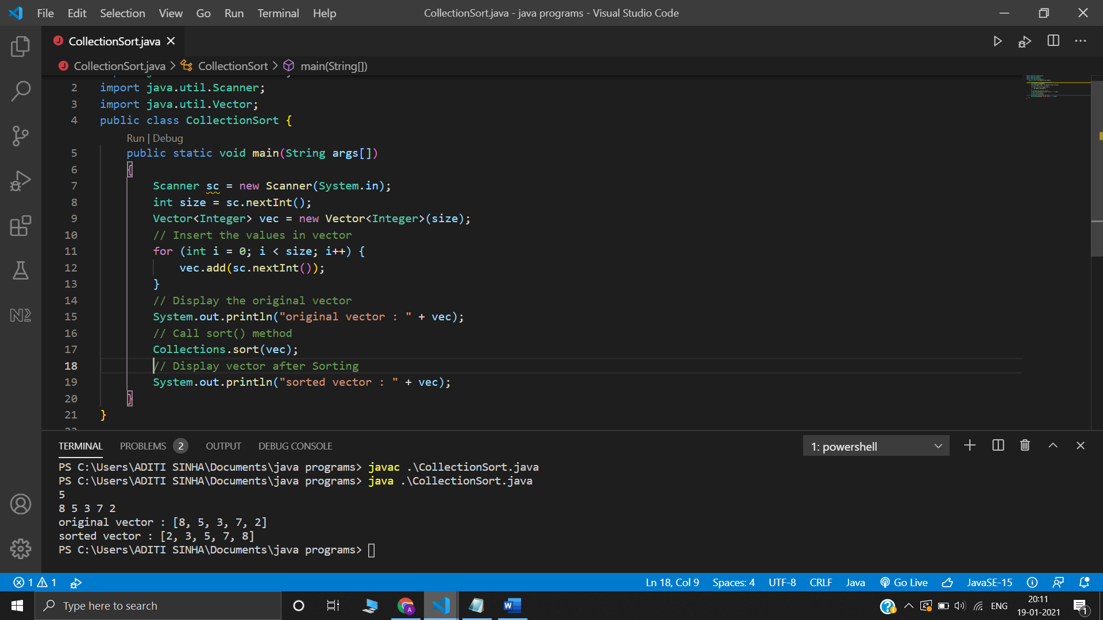

**Ques 2 –**

import java.util.Scanner;

public class ExceptionUsingThrow {

static void check(int percentage)

{

if(percentage < 35)

{

throw new ArithmeticException("Fail");

}

else

{

System.out.println("Pass");

}

}

public static void main(String[] args) {

Scanner s = new Scanner(System.in);

int percentage = s.nextInt();

check(percentage);

}

}

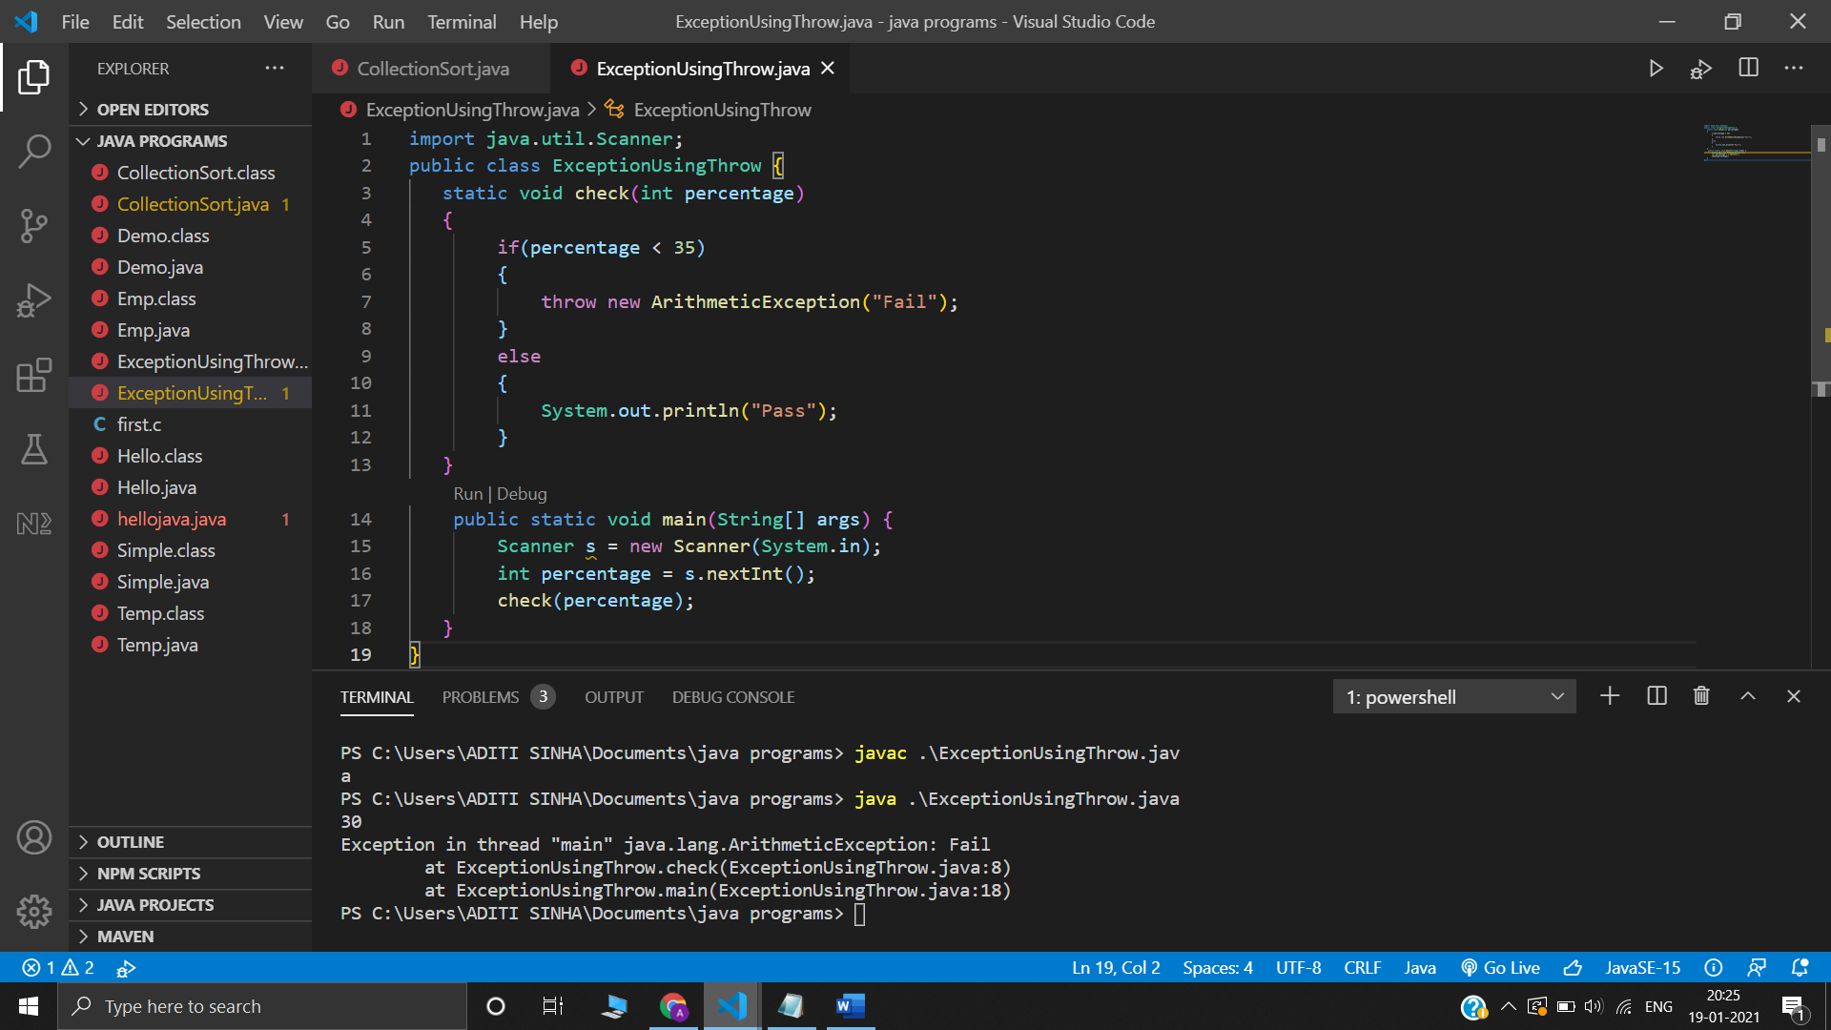

**Using Throws**

import java.util.Scanner;

public class ExceptionUsingThrows {

public static void main(String[] args) throws ArithmeticException {

Scanner sc = new Scanner(System.in);

int d1 = sc.nextInt();

int d2 = sc.nextInt();

System.out.println((d1 / d2));

}

}

